Brake Performance Control Function – CGEA1.3

Functional Description

The purpose of the Brake Performance Control function is to record distance traveled to bring the car to a complete stop from pre-selected speed thresholds, which are similar to the results that a drag strip would provide at the end of a run. The Brake Performance Control function is an application that is located under the Track Apps Menu. The function records Time and g-force for the standard performance tests listed below:

For US units:
- 60-0 MPH
- 100-0 MPH
For Metric units:
- 100-0 km/h
- 200-0 km/h

The user will have a choice of selecting any or all of the end points for data acquisition. Once a test point is selected, the user will be asked to accelerate until the vehicle reaches a start point. Once that is achieved, the instrument cluster will instruct the user to apply the brakes with a message on the cluster and a tone. Once the brakes are applied and the vehicle has slowed to the start speed, the timer will calculate distance, peak deceleration and time until the vehicle is stopped. The instrument cluster will attempt to collect timer information for as many of the brake functions that the selected endpoint will allow. The remaining timers will not be collected and will display blank.

At the end of the test, the result of the last run test criteria will get displayed. Once the vehicle is brought to a stop, the user will have the option of viewing the complete results, compare last run data with average and all-time best data.

The Track Applications Results Display function has following sets of data stored and displayed:

- Last run data: This data is stored at the successful completion of a brake performance run. This entire set of data is overwritten at the next run. If any values are not completed in a run, the values will be blank. The last run data should be retained until the next run overwrites it.
- Average Data: This field shows the average braking distance, braking time and deceleration values since the last user reset/clearing of data.
- Best Data: This field shows the best braking distance, braking time and deceleration values since the last user reset/clearing of data.
- All Time Best Data: This field shows the all-time best values for braking distance, braking and braking time for each end point. It automatically gets updated every time a better result is recorded from the previous one. Each metric is handled and saved separately. This data can never be erased or cleared from cluster memory.

The View/Clear results screens are only available when the vehicle is in stationary position (not moving). If the vehicle speed exceeds 8 KPH while the cluster is displaying the results screen, the cluster shall return to the Track Apps Menu selection screen.

The Brake Data acquisition function is only available with key in the Run/Start position. The Brake Performance feature is not available with MyKey.

The Brake Performance Control Function correlates the VehOverGnd_V_Est , VehLongComp_A_Actl and VehLatComp_A_Actl HS-CAN signals from the ABS_ESC, the BpedDrvAppl_D_Actl signal and the Operational mode to process the timer function.

Interfaces

Interface Context Diagram (I/O Block Diagram)
Figure 1.0 Brake Performance Control Function Context Diagram
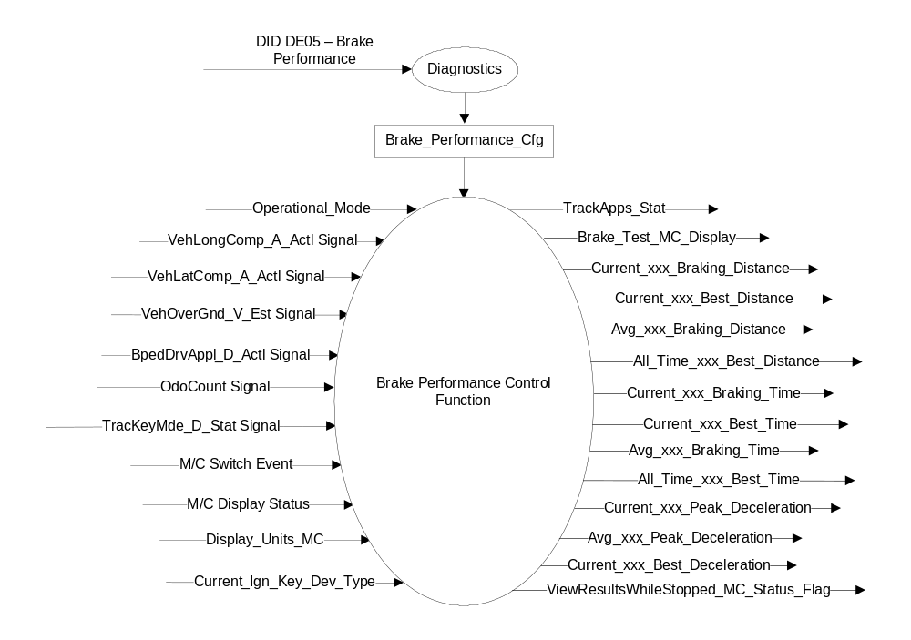

Inputs
- INTERNAL:
  - Operational_Mode: Refer to section Operational Modes
  - Current_Ign_Key_Dev_Type: Used to indicate the type of key currently in use in the vehicle. See MyKey Control Function SPSS for further definition
  - Brake_Performance_Cfg
  - M/C Display Status
  - M/C Switch Event
  - Display_Units_MC - Refer to the Display Unit Selection Control Function – CGEA1.3 STSS for more information.
- MUX messages on the HS_CAN Bus

- VehLongComp_A_Actl Signal
Signal Name | Size (bits) | Detail | Units | Res. | Offset | State Encoded | Min | Max
VehLongComp_A_Actl | 10 |  | m/s^2 | 0.035 | -17.9 |  | -17.9 (0x0) | 17.835 (0x3FD)
 |  | Unknown |  |  |  | 0x3FE
 |  | Fault |  |  |  | 0x3FF

- VehLatComp_A_Actl Signal
Signal Name | Size (bits) | Detail | Units | Res. | Offset | State Encoded | Min | Max
VehLatComp_A_Actl | 10 |  | m/s^2 | 0.035 | -17.9 |  | -17.9 (0x0) | 17.835 (0x3FD)
 |  | Unknown |  |  |  | 0x3FE
 |  | Fault |  |  |  | 0x3FF

- VehOverGnd_V_Est Signal
Signal Name | Size (bits) | Detail | Units | Res. | Offset | State Encoded | Min | Max
VehOverGnd_V_Est | 10 |  | kph | 0.01 | 0 |  | 0 (0x0) | 655.33 (0xFFFD)
 |  | Unknown |  |  |  | 0xFFFE
 |  | Fault |  |  |  | 0xFFFF

- BpedDrvAppl_D_Actl Signal
Signal Name | Size (bits) | Detail | Units | Res. | Offset | State Encoded | Min | Max
BpedDrvAppl_D_Actl | 2 |  | SED | 1 | 0 |  | 0 (0x0) | 3 (0x3)
 |  | Not_Allowed |  |  |  | 0x0
 |  | Driver_Not_Braking |  |  |  | 0x1
 |  | Driver_Braking |  |  |  | 0x2
 |  | _Not_Allowed |  |  |  | 0x3

- TracKeyMde_D_Stat Signal
Signal Name | Size (bits) | Detail | Units | Res. | Offset | State Encoded | Min | Max
TracKeyMde_D_Stat | 2 |  | SED | 1 | 0 |  | 0  (0x0) | 3  (0x3)
 |  | ModeNotDetermined |  |  |  | 0x0
 |  | Active |  |  |  | 0x1
 |  | NotActive |  |  |  | 0x2
 |  | NotUsed |  |  |  | 0x3

Outputs
- Brake_Test_MC_Display – Main display variable that determines what needs to be displayed for Brake perf.
- Current_xxx_Braking_Distance – Variable that holds the value of current braking distance of selected end point.
- Current_xxx_Best_Distance – Variable that holds the value of best braking distance since last reset/clearing of data of selected end point.
- Avg_xxx_Braking_Distance – Variable that holds the value of average braking distance since last reset/clearing of data of selected end point.
- All_Time_xxx_Best_Distance – Variable that holds the value of all-time best braking distance for selected end point.
- Current_xxx_Braking_Time – Variable that holds the value of current braking time of selected end point.
- Current_xxx_Best_Time – Variable that holds the value of best braking time since last reset/clearing of data of selected end point.
- Avg_xxx_Braking_time – Variable that holds the value of average braking time since last reset/clearing of data of selected end point.
- All_Time_xxx_Best_Time – Variable that holds the value of all-time best braking time for selected end point.
- Current_xxx_Peak_Deceleration – Variable that holds the value of current deceleration of selected end point.
- Current_xxx_Best_Deceleration – Variable that holds the value of best deceleration since last reset/clearing of data for selected end point.
- TrackApps_Stat – variable that determines status of Track apps screens.
- ViewResultsWhileStopped_MC_Status_Flag – warning flag passed on to the warning arbitrator.

Function/Performance

Operational Modes

Mode | Differentiating Vehicle Conditions
Sleep Mode | Brake Performance Test Display messages Inactive
Limited Mode | Brake Performance Test Display messages Inactive
Normal Mode | Brake Performance Test Display messages Active / Inactive
Crank Mode | Brake Performance Test Display messages Active / Inactive

Voltage Levels

Refer to Cluster Features table located in the Operational Modes and Voltage Range Strategies section in this SPSS.

Human-Machine Interface

Visual

Indicator Graphics / Display Format
Example graphics (not all graphics are shown here):

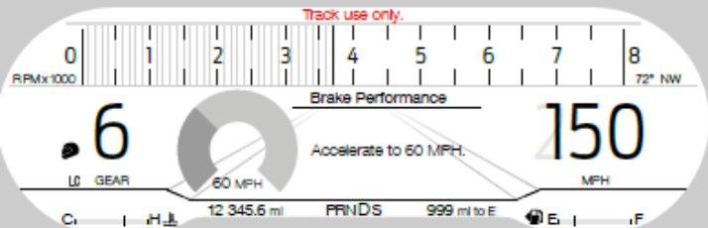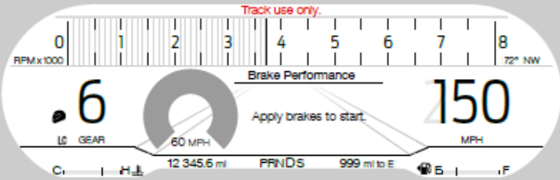

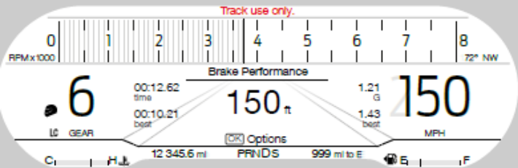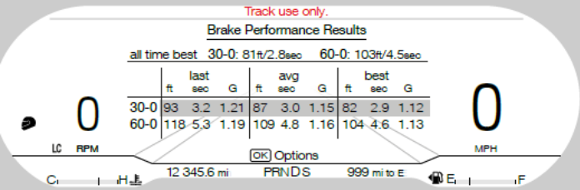

Indicator Color Coordinates

Indicator Characteristics

Audio

None

Switch Control Logic

Not applicable.

System Accuracy

- The Brake performance results shall be displayed in the format of XX.X seconds, YYY.Y (Feet for English units, meters for Metric units) and Z.ZZ G.
Test End Points:
- 60-0 mph: The data acquisition shall start when the vehicle speed reaches 96.56 KPH and stop when vehicle speed reaches 0 kph
- 100-0 mph: The data acquisition shall start when the vehicle speed reaches 160.9 KPH and stop when vehicle speed reaches 0 kph.

Operation: Performance and Functional

Subsystem Algorithm Flowchart / State Diagram
Figure 1.1 Brake Performance Selection Criteria
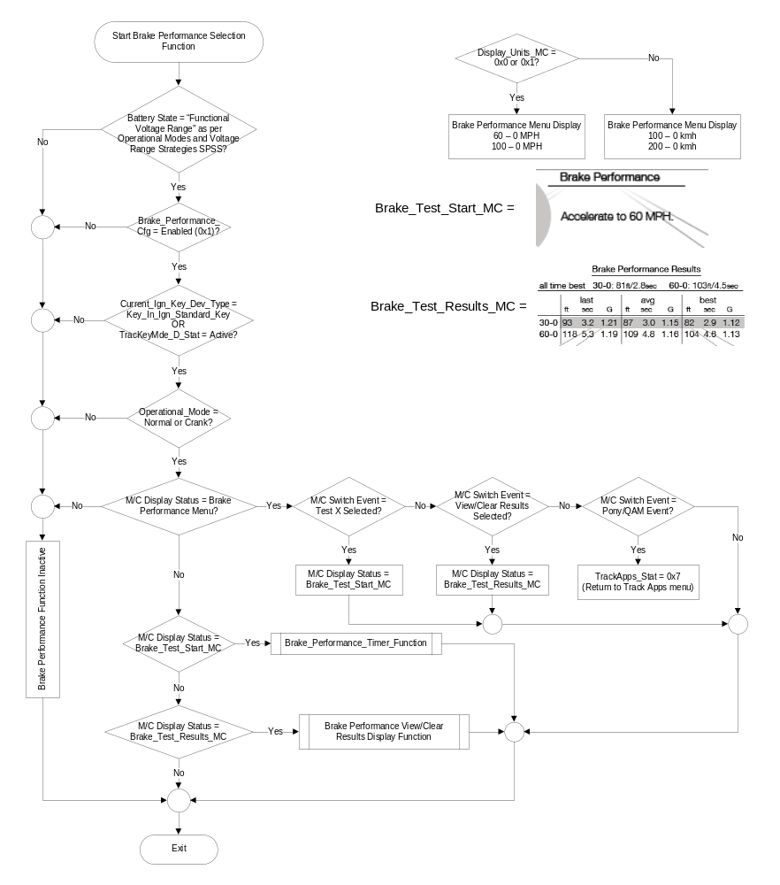
Figure 1.2 Brake_Performance_Timer_Function Subroutine
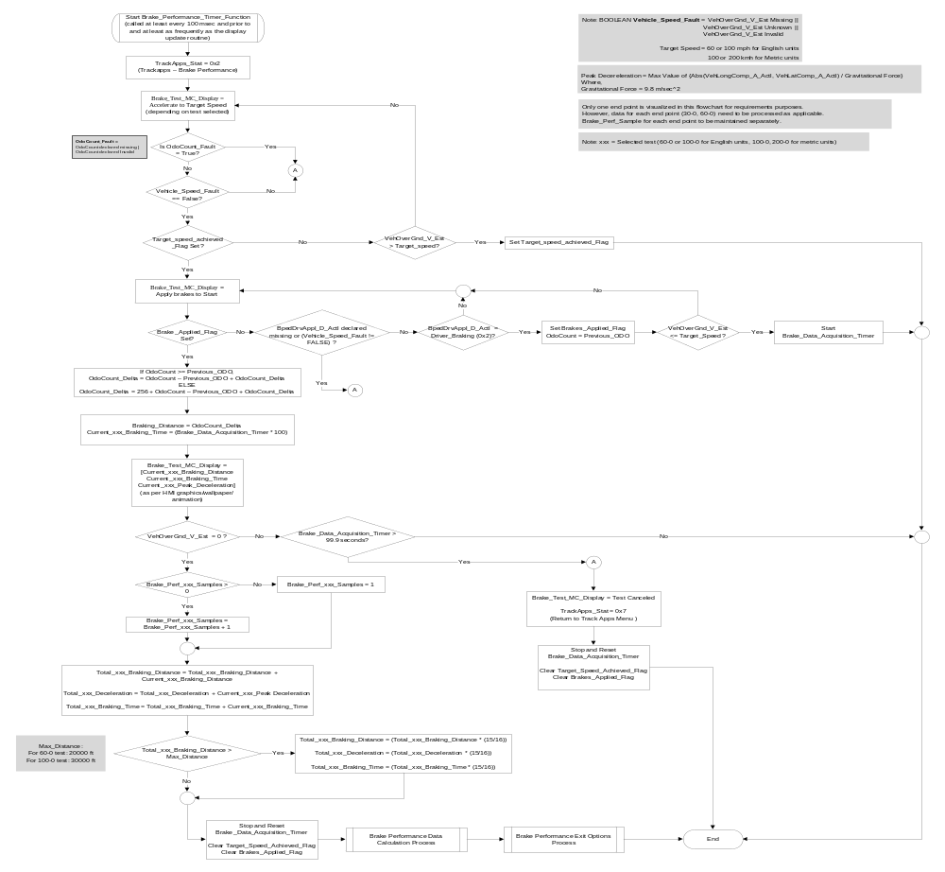

Figure 1.3: Brake Performance Data Calculation Sub-Function

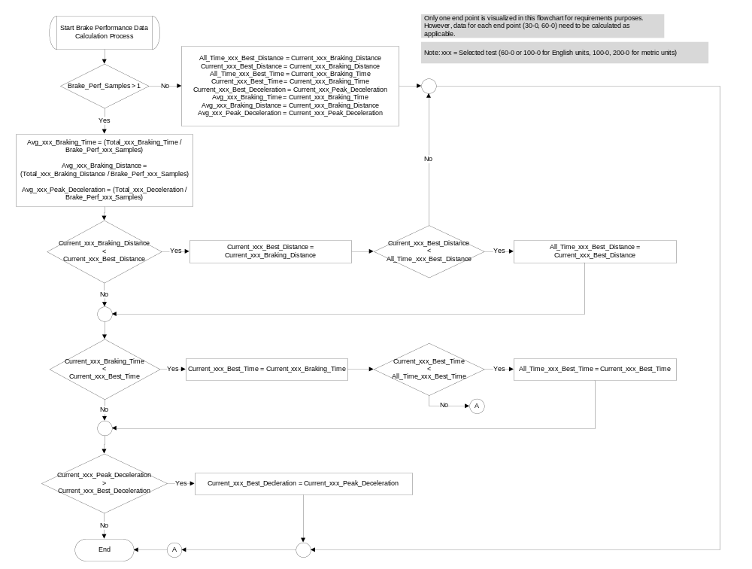

Figure 1.4: Brake Performance Exit Options Sub-Function

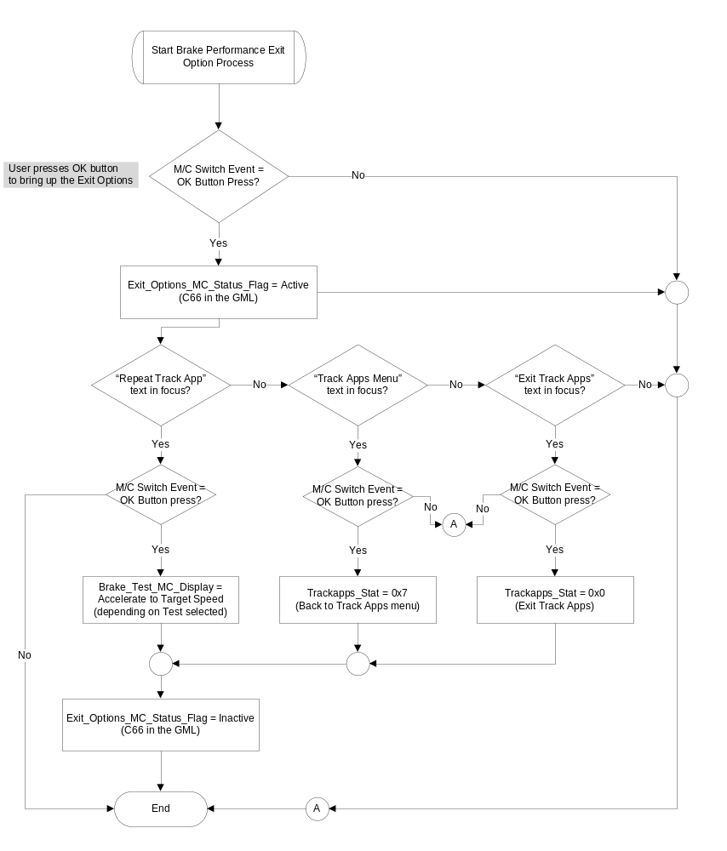

View/Clear Results Display Menu
The following sets of data are stored and displayed for each of the test points in the brake performance feature:

- Last run data: This data is stored at the successful completion of a brake performance run. This entire set of data is overwritten at the next run. If any values are not completed in a run, the values will be blank. The last run data shall be retained over ignition cycles until over written by next successful run or cleared by the user.
- Average Data: This field shows the average braking distance, braking time and deceleration values since the last user reset/clearing of data.
- Best Data: This field shows the best braking distance, braking time and deceleration values since the last user reset/clearing of data.
- All Time Best Data: This field shows the all-time best values for braking distance and braking time for each end point. It automatically gets updated every time a better result is recorded from the previous one. Each metric is handled and saved separately. This data can never be erased or cleared from cluster memory.

Figure 1.5 Brake Performance View/Clear Results Display Function

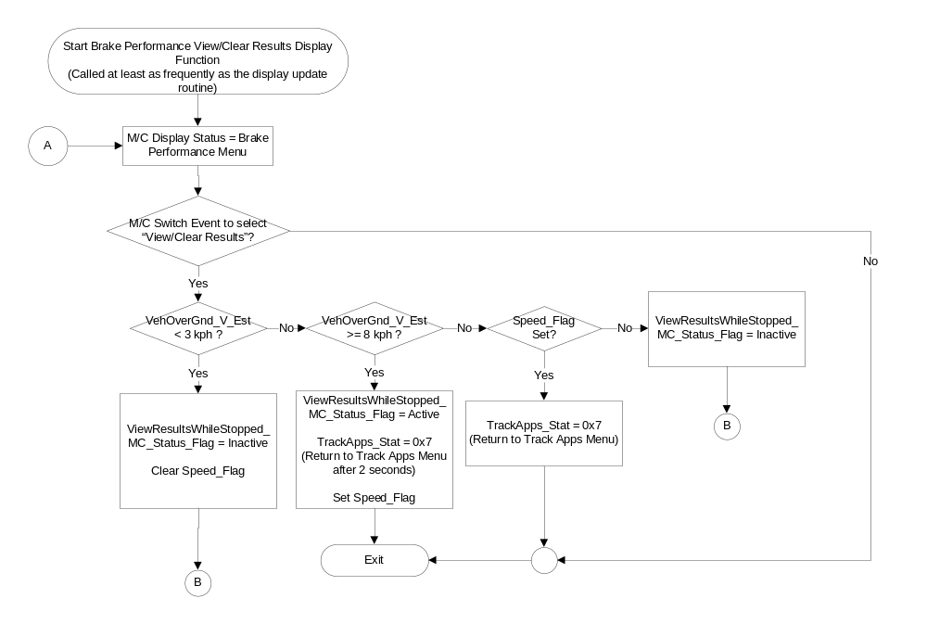
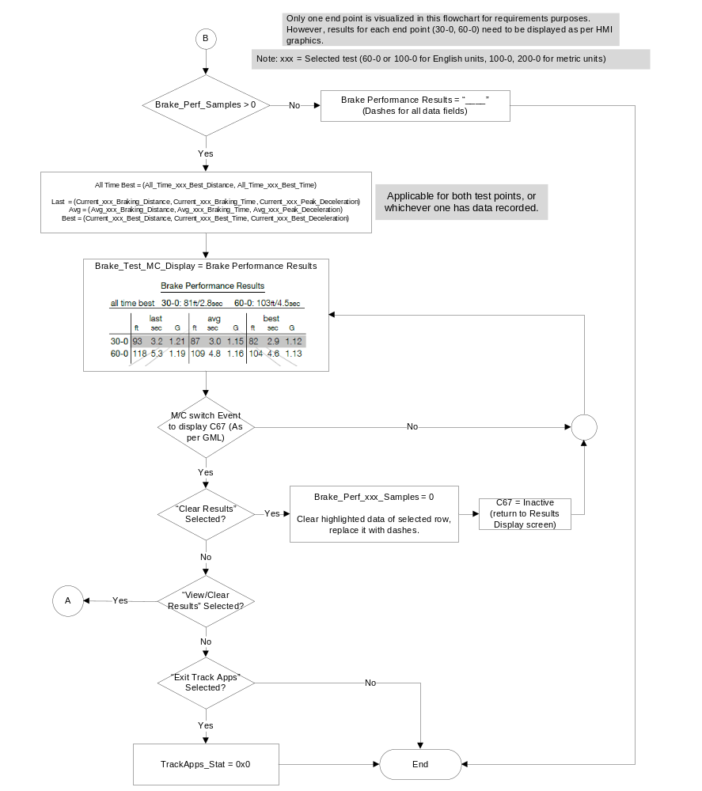

Operation Description (supports algorithm flowchart /state diagram)

- View/Clear Results while Stopped Status Flag to Display Mapping

ViewResultsWhileStopped_  MC_Status_Flag | MC Message ID
Active | W3263

- All the screens under the Brake Performance menu shall display “Track Use Only” on the screen at all times.
- The Brake_Data_Acquisition_Timer is defined as 1 timer. However, supplier may use as many timers as required to record data for the selected Test end points.
- The cluster may use the odometer function or the following formula to calculate distance traveled:
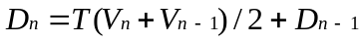
Where
V_{n} = Current Vehicle Speed based on VehOverGnd_V_Est
T = Periodic rate of the CAN message
D_{n} = Current distance traveled
- Distance measured for Brake Performance test in English units shall be in units of feet and in units of meters for test performed in Metric units.

- A direct form 1 filter shall be applied to the input signals as follows to get an accurate accelerometer value displayed:

a[1] * y[n] = ( b[1] * x[n] ) + ( b[2] * x[n-1] ) + ( b[3] * x[n-2] ) - ( a[2] * y[n-1] ) - ( a[3] * y[n-2] ) Where,
a = denominator coefficients
b = numerator coefficients
x(n) = Unfiltered signal - VehLongComp_A_Actl or VehLatComp_A_Actl
y(n) = filtered signal - VehLongComp_A_Actl or VehLatComp_A_Actl
Once the values are generated after applying the filter, a roll (for lateral movement) and pitch (for longitudinal movement) correction multiplier is then applied to get the final data.
The coefficient constants and multiplier are program dependent, hence, are provided directly by the program based on track tests and other factors.

The running filer is applied once 3 values of the valid unfiltered signal are received.
The filter may be applied at the same rate the display update function.

- The cluster shall display a status bar of the test completion similar to screen 5 in section 1.3.3.2 indicating how close to the target the customer is. The “Elapsed Time” is not dynamic, however, it shall display the time taken once the test criteria has been successfully completed.
- If the vehicle does not reach 0 KPH during the Data Acquisition period and the brake timer exceeds 99.9 seconds, the test shall be considered canceled, and data will not be recorded. The cluster shall return to the Track Apps menu screen.
- At any given time during the Data Acquisition process if any of the signal is declared missing, invalid or unknown, the test shall be stopped and considered canceled and no results will be recorded for that test until a test is deemed successfully complete.
- It is not required to display the progress bar (example: screen 4) while vehicle is accelerating to reach target speed. All screens shown in section 1.3.3.2 are for example purposes only and may be changed as required per program needs.
- The All Time Best Data is saved in the cluster EEPROM/NVM memory and is never cleared.
- The cluster shall only clear highlighted data of selected row when “Clear Results” is selected.
- The Brake Performance feature shall not be available if Brake_Performance_Cfg is set to disabled (0x0).
- The Brake Performance feature shall not be available if the vehicle is driven using My Key.

Function Safety Classification (EMC)

Class B

Memory Storage
Parameter Name | Description | Value at Battery Connect | Value at Module Wake-up
VehLongComp_A_Actl Signal | Input longitudinal acceleration sent from the ABS_ESC. | -17.9 m/s^2 (0x0) | -17.9 m/s^2 (0x0)
VehLatComp_A_Actl Signal | Input latitudinal acceleration values sent from the ABS_ESC. | -17.9 m/s^2 (0x0) | -17.9 m/s^2 (0x0)
VehOverGnd_V_Est Signal | Vehicle speed input from ABS_ESC. | 0 kph (0x0) | 0 kph (0x0)
BpedDrvAppl_D_Actl Signal | CAN Input from ABS. | Not_Allowed (0x0) | Not_Allowed (0x0)
TracKeyMde_D_Stat signal | Input from BCM providing status of TracKey | ModeNotDetermined (0x0) | ModeNotDetermined  (0x0)
Brake_Test_MC_Display | Different text messages displayed during various states of the brake performance test. | Inactive | Inactive
Current_xxx_Braking_Distance | Output variable that holds the value of current braking distance of selected end point. | 000.0 ft or m | 000.0 ft or m
Current_xxx_Best_Distance | Output variable that holds the value of best braking distance since last reset/clearing of data of selected end point. | 000.0 ft or m | Use Stored value
Avg_xxx_Braking_Distance | Output variable that holds the value of average braking distance since last reset/clearing of data of selected end point. | 000.0 ft or m | Use Stored value
All_Time_xxx_Best_Distance | Output variable that holds the value of all-time best braking distance for selected end point. | Use Stored Value | Use Stored Value
Current_xxx_Braking_Time | Output variable that holds the value of best braking time since last reset/clearing of data of selected end point. | 00.0 sec | 00.0 sec
Current_xxx_Best_Time | Output variable that holds the value of best braking time since last reset/clearing of data of selected end point. | 00.0 sec | Use Stored value
Avg_xxx_Braking_Time | Output variable that holds the value of average braking time since last reset/clearing of data of selected end point. | 00.0 sec | Use Stored value
All_Time_xxx_Best_Time | Output variable that holds the value of all-time best braking time for selected end point. | Use Stored Value | Use Stored Value
Current_xxx_Peak_Deceleration | Output variable that holds the value of current deceleration of selected end point. | 0.00 G | 0.00 G
Current_xxx_Best_Deceleration | Variable that holds the value of best deceleration since last reset/clearing of data for selected end point. | 0.00 G | Use Stored Value
TrackApps_Stat | Please refer to the “Info On Demand Selection Control Function – CGEA1.3 – S550 Specific” STSS for more information.
ViewResultsWhileStopped_  MC_Status_Flag | Used to control the state of the display for the Message Center arbitrator | Inactive | Inactive
Brake_Performance_Cfg | State indicator for feature presence controlled via CAN at EOL at VO plant. Set to Disabled at Cluster Supplier Manufacturing Plant | Use Stored Value | Use Stored Value
Operational_Mode | 4 state indicator for cluster operational mode | Limited | Limited or Normal or Crank

Parameter Name | Description | Range | Units | Res | Init Value
Brake_Data_Acquisition_Timer(s) | Timer(s) to keep track of brake tests | 0-99.9 | sec | 0.1 | 0

Prove Out

No

Error Handling

Missing Message Strategy

The signals will be declared missing as per the Diagnostics section of this SPSS.

DTCs states and history will be determined as per the Diagnostics section of this SPSS.

If Brake_Performance_Cfg = Disabled, the cluster shall never log a missing message DTC due to this feature.

Invalid Message Strategy

The signal data will be declared invalid as per the Diagnostics section of this SPSS.

DTCs states and history will be determined as per the Diagnostics section of this SPSS.

If Brake_Performance_Cfg = Disabled, the cluster shall never log an invalid data DTC due to this feature.

Unknown Message Strategy

The signal data will be declared unknown as per the Diagnostics section of this SPSS.

DTCs states and history will be determined as per the Diagnostics section of this SPSS.

If Brake_Performance_Cfg = Disabled, the cluster shall never log an unknown data DTC due to this feature.

Diagnostics

Self Test
None

Engineering Test Mode
Reference section “Dealer / Engineering Test Mode (ETM)”

Part II Performance
Reference Part II Diagnostic Specification

Supported Diagnostic Trouble Codes (DTCs)
DTC | Description
C12100 | Lost Communication with ABS_ESC
C41581 | Unknown Data Received from ABS_ESC
C41500 | Invalid Data Received from ABS_ESC
C10000 | Lost Communication with PCM

DID DEXX
Block  Num | Block Description | Size (bits) | Byte | Bit | State: Description | "0" | "1" | Default | Comments
PACKETED BLOCKS
$XX | Option Content (B&A) | 1 | * | * | Brake_Performance_Cfg | Disabled | Enabled | Disabled
*Byte and bit location to be identified in Part II Specification for this cluster

Reference Specification

- Func. Criticality EC-0048
- Mod. PWR-up / Reset EC-0049
- Low-High Vol. Perform. EC-0058
- Oper. Voltage Perf. IS-0052
- Oper. Voltage Func. IS-0053
- Symbol Usage 01-0238 / 01-0239
- Symbol Leg. 01-0240
- Placement - Parts Loc. 03-0001
- Glare/Reflections 16-0068
- Reflection 17-0018
- Harmony: Graphics / Font / Ill. 17-0040
- Ergo - Access. 17-0052
- Ergo - Operablility 17-0053
- Control & Display Loc. 17-0060
- Logical grouping Function and Usage 17-0062
- Assoc. of Controls with Disp. & elem. 17-0063
- Ill. Controls & Disp. 17-0074
- Id. Legibility 17-0081
- ID. Coding / Labeling 17-0083
- Logic of Op. 17-0120
- Op. Stereotypes 17-0121
- Interpretation 17-0122
- Feedback 17-0124

Revision History

SPSS Module Revision History

Revision Level | Name | Change Description | Date
1.0 | V. Patel | Initial version for 2018 S550 MCA cluster program.  Feature owner: Daugherty, Keith | 03/10/2016

